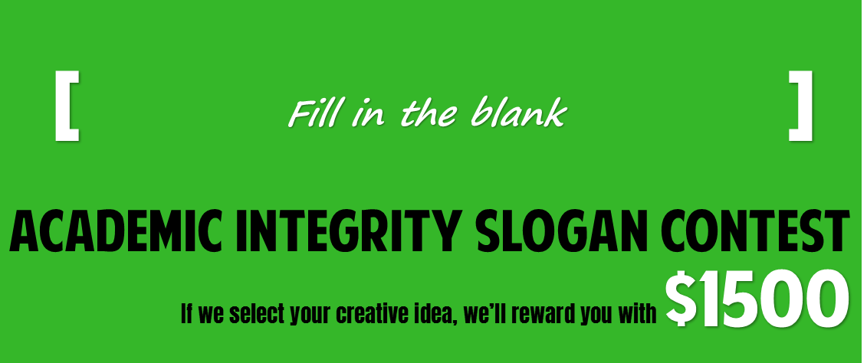
QUESTIONS?
Contact
academicintegrity@cod.edu
CONTEST RULES
Please read before entering
CONTEST DATES
Aug. 21 - Sept. 8
Accepting entries
Sept. 20
Winner announced
PRIZES
Grand Prize (1)
$1500 award
Runners up (2)
$500 award
MORE INFORMATION
Visit
www.codlrc.org/academichonesty
Fill out this form & click submit to enter

Contact information
name
e-mail | must be @dupage.edu
phone #

Idea Details
slogan
brief idea
description
I acknowledge that I have read and agree with the contest rules and regulations

