Health Research Simplified @ the COD Library
Library Catalog (http://codlrc.org/catalog)
The general collection has biographies, exercise, self-help, nutrition/cookbooks, and texts in many different formats (books, audio books, e-books, DVDs, software). You can find items, both fiction and nonfiction, designed for all ages and education levels (the very young, kids, teens, adults, seniors, students, professionals, and consumers).
TIP: keyword search for disease/condition (to further refine your search, add AND treatment or AND diagnosis) for example: migraine AND treatment
TIP: try a subject search for a disease/condition and add: --popular works (example: diabetes—popular works) to limit results to items designed for the general public/health consumers
Try doing a subject search for stroke—popular works
TIP: Click on the title of an item to display the full record for the item. Look on the right-hand side of the entry at the “More like this” section for suggested subjects and a link to similar items
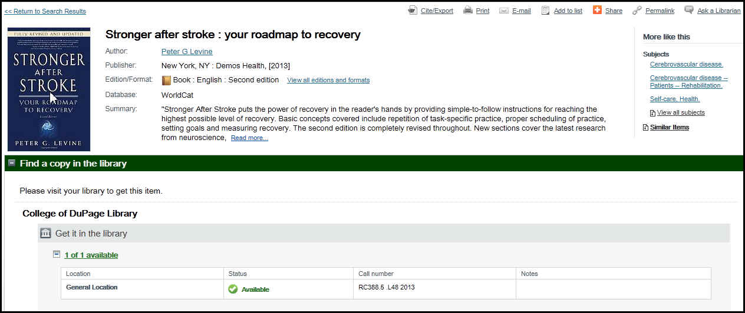
Make note of the LOCATION, STATUS and CALL NUMBER of the item for quick retrieval!
TIP: You can limit your search to specific types of items (books & e-books, journals or magazines, articles, videos, audiobooks) and to where items are located (COD Library only, COD Library & I-SHARE, or All Libraries)
Library reference materials are well-indexed, current, concise, and highly credible. They provide overviews (disease/condition/procedure descriptions, symptoms, diagnosis, treatment, and prognosis), definitions, specific information and addresses. Try the online medical encyclopedia articles found in GVRL (Gale Virtual Reference Library)
The C.O.D. Library staff is here to help! Stop by the main reference desk, email Debra or set up an appointment. You are not alone in the research process!
Health & Medicine Databases (accessible from home using your C.O.D. Library card)

Library homepage Databases (green tab) Health Health and Medicine http://codlrc.org/databases/medicine

Get electronic access to reliable, trusted medical reference materials. The COD Health databases include full-text articles from health and medical journals and magazines, full-text entries from numerous Gale reference books, health-related pamphlets, and streaming videos.
TIP: Recommended databases for Consumers include:
Gale Virtual Reference Library--GVRL is a collection of online reference books on a variety of topics including Medicine. Individual entries from these resources can be printed and emailed
Health Source: Consumer Edition--Aimed at consumers and patients, this database provides full-text access to nearly 80 consumer health magazines, over 1,000 pamphlets on various medical topics, nearly 130 health reference books, and Merriam-Webster's Medical Desk Dictionary.
Websites
Tips to Finding Information on the Internet
• Isolate key concepts and words to be searched, including word variations and synonyms. Be as specific as you can (for example search “prostate cancer treatment” instead of “cancer”)
• Determine the type of information needed (general or technical information? Information for an adult audience or children? Adolescents? Seniors?)
• Use a search engine like Google http://www.google.com/ or take advantage of established, pre-selected Internet collections like:
- MLA Top Health Web Sites <https://www.mlanet.org/resources/medspeak/topten.html> from the Medical Library Association
- CAPHIS Top 100 List: Health Websites You Can Trust <http://caphis.mlanet.org/consumer/index.html> from the Consumer and Patient Health Information Section of the MLA
- Health & Wellness Internet Sites <http://www.codlrc.org/HS/consumer/web> recommended by COD Library's Health Sciences Librarian
• Carefully evaluate the credibility of the source and the quality of the information retrieved
- “Find and Evaluate Health Information on the Web” from the Medical Library Association https://www.mlanet.org/resources/userguide.html
MEDLINEplus <http://www.nlm.nih.gov/medlineplus/>
Provides access to 900+ health topics, medical encyclopedias and dictionaries, and links to self-help groups, clinical trials, scholarly journal articles, lists of hospitals and physicians, health and information in Spanish and other languages. Includes listings of diseases & conditions by body system. A one-stop-shop for quality health information!

