

Selected Resources for the
Associate Degree in Nursing (ADN) Program
2016

The College of DuPage Library is located in the Student Resource Center (SRC) building adjoining the Berg Instructional Center (BIC). An enclosed walkway (bridge) joins the SRC and Health Science building on the second floor. Two additional Library entrances are located on the North and South sides of the Library’s upper floor (each entrance is near an elevator and stair access). The library is accessible for students with disabilities, has an internal elevator as well as stair access to its upper floor, and houses a variety of assistive devices for special needs students. Close proximity, multiple entrances, and special-needs accommodations make accessing Library resources easy for Nursing students and faculty.

During the academic year, the Library is open every day of the academic year at the following times:
Regular Hours:
Monday - Thursday | 7:30am - 10:00 pm
Friday | 7:30 am - 4:30 pm
Saturday | 9:00 am - 4:30 pm
Sunday | 12 noon - 6:00 pm

For a current listing of holiday Library closings and adjusted vacation operating hours (when classes are not in session), consult http://www.codlrc.org/hours.

The Library Reference staff consists of 20 (10 full-time and 12 part-time) professional librarians and 11 reference assistants. The Library has two reference stations located on the main level and a third reference desk located on the Library’s second level. A minimum of one librarian and one reference assistant are scheduled upstairs and down with additional staffing added during peak service hours.

The library liaison to faculty and students in the ADN Program is Debra J. Kakuk Smith, Professor, Reference Librarian. Smith is an experienced instructor and medical librarian. For more information see http://codlrc.org/smith

Instruction and Reference Services

Students can access the C.O.D. Library’s resources 24 hours a day, 7 days a week via the Internet at the URL http://www.cod.edu/library. Students must use their library card barcode number to access electronic databases and to place holds, I-Share and Interlibrary Loans (ILL).

Students receive reference assistance in person, by phone, email, or instant message during library operating hours. The electronic (email) reference service is called “Ask a Librarian.” “Ask a Librarian” questions are answered throughout open hours of operation and students can expect a reply to their questions within 24 hours of submission. Users may instant message Librarians during open hours of operation using AOL Instant Messenger, Yahoo!, MSN, Google Talk, or Jabber chat services. Students may directly contact particular librarians as well. Professor Smith’s contact information is: Debra J. Kakuk Smith, SRC 3149, smithkak@cod.edu, (630) 942-4305.

An online Nursing Resources Guide located at http://www.codlrc.org/HS/nursing provides students and faculty with: catalog and database links, research tutorials, recommended reference materials in the College of DuPage collection, Internet sites (including associations, organizations, consumer/general information and reference sites), health information literacy information, and APA citation style tips. The materials range from those suitable for patient education to information geared to health science students and practicing professionals. The Nursing guide contains materials pertaining to their current studies as well as professional development resources. This research guide was created and is currently maintained with direct input from the Nursing Faculty.

The Library has seating for 500+ students, 8 different group study rooms capable of seating 4 to 12 students (for study room usage guidelines and room descriptions see: http://www.codlrc.org/spaces/group), plus a seminar room available for faculty reservations. Students have access to 100+ Gateway Workstations throughout the two floors of the main campus COD Library. In addition, wireless laptops with access to all library resources are available for student checkout and use within the library (including the small group rooms, quiet and silent study areas). The Library offers free wireless access for all users. The Library workstations and laptops have productivity software (Microsoft Office Suite, Adobe Suite) installed on them. A variety of printing options (black/white, color, photocopies, flat-bed scanners) are available. Students can also load interactive, educational software and check-out headphones at the circulation desk. The workstations have software that reinstalls an original build every time the workstations are shut down or restarted. Reference librarians and computer support/print services staff are available to assist students with computer/technology-related questions.

A new Media Lab, http://codlrc.org/lab, is located in the Library’s lower level and is freely available to COD Library card holders. COD students can create and edit all kinds of digital audio, video, and images in the Lab containing four imaging stations and two separate A-V editing suites. The Lab features high-powered Mac workstations and popular media production software like Adobe's Creative Cloud suite and Avid Pro Tools. Students can use high quality photo scanners, drawing tablets, a 3D scanner, DSLR cameras, microphones, and other audio peripherals.

Faculty members are encouraged to schedule specialized library instruction and research assistance with the Health Science Division Librarian, Debra J. Kakuk Smith. The Library and Health Sciences faculty work together to create quality information literacy assignments that assist the Nursing students in becoming lifelong learners. The library has six technical classrooms, including five hands-on computer labs equipped with enough workstations for (20-40 students) as well as an instructor station and digital projector. An additional library classroom is available with an instructor workstation, digital projector and three-dimensional document reader for demonstration classes. On and off campus classroom visits and instruction sessions can be arranged by contacting Debra J. Kakuk Smith.

Each semester of the academic year, including summer, the library offers free computer workshops for students to become Smart Online Searchers. Students may choose to attend, in-person or online, workshops on a wide-range of topics such as Introduction to the Library, Research Strategies, APA Documentation, Consumer Health, Job Seeking, Internet Basics and Advanced Online Search Strategies. Classes are offered during the day, evenings and weekends. Students can view information about current workshop offerings at http://codlrc.org/sos

Journals, Periodicals and Online Database Offerings

The College of DuPage Library provides print journals and periodicals in support of the ADN curriculum. Students in the program also have access to periodicals through electronic databases. Through the College of DuPage Library Home Page (http://www.cod.edu/library/), ADN students have 24 hour, 7 days a week access to the College of DuPage’s Library catalog, article databases, full-text e-books, journal articles and all other electronic educational materials.

The College of DuPage Library subscribes to 120+ electronic databases and approximately 54,583 electronic books. Nursing students have access to twenty-three health and science related databases such as the Cumulative Index to Nursing and Allied Health Literature (CINAHL) Complete, Gale’s Academic OneFile, HealthSource: Nursing/Academic and Consumer (from EBSCO), ScienceDirect, Micromedex Health Care Series (including CareNotes), The Joanna Briggs Institute EBP Database, and MEDLINE. Full text access is also available to numerous journal articles on line which expands the library’s periodical holdings for students and faculty.

In addition to “traditional” periodical databases, the C.O.D. Library provides Nursing students with access to ADAM Interactive Physiology (Networked version), full-text reference book access using The Gale Virtual Reference Library, and test preparation materials available in the Learning Express Library. Streaming Videos are also available from a variety of electronic video databases including Nursing Education in Video from Alexander Street Press. For descriptions of COD Library’s Online Video databases, go to: http://codlrc.org/databases/videos-online

Nursing Program Journals

The College of DuPage subscribes to 435 print periodicals. ADN students have access to approximately 380 online and 12 print journals and magazines specific to Nursing. Many other Health and Medicine-related titles are available.

The Library’s Nursing electronic periodical holdings are available in a conveniently arranged subject list at: http://sc9jf5ze6e.search.serialssolutions.com/?V=1.0&L=SC9JF5ZE6E&N=100&SS_searchTypeJournal=yes&S=SC&C=HE0059

For a list of print Nursing periodicals, see Excel Workbook: Nursing Library Holdings 2016 located at http://www.codlrc.org/hs/nursing.

Interlibrary Loan (ILL) & I-SHARE

Students enrolled in the Nursing Program have 24-hour access to our Interlibrary Loan (ILL) Department. Students and faculty are able to search and submit their requests for journal and periodical articles, book chapters and books electronically from COD workstations or at home. The College of DuPage has online access to thousands of Online Computer Library Center (OCLC) Libraries in our local area and around the world. These libraries provide our students and staff with access to millions of items that are not available in our collection. The Ariel Document Delivery System allows our interlibrary loan department to request and receive student interlibrary loan materials electronically from locations worldwide. Documents received through Ariel can also be emailed directly to students and faculty.

In addition to traditional ILL, students and faculty now have access to I-Share borrowing. When searching COD’s catalog, Illinois holdings (including over 11.5 million unique bibliographic records and more than 36 million item records, representing the holdings of 82 Illinois College and Research Library I-Share member institutions) as well as international OCLC holdings appear. COD library users can request books from these participating Illinois libraries using their free I-Share accounts. While traditional ILL requests can take 5-10 days to arrive, I-Share requests typically arrive in 2-5 days.

Students and faculty may pick up their materials at the College of DuPage Library for free, or have the materials mailed to their homes for a minimum fee of $2.00 per package. For materials that must be returned, items can be mailed, or dropped off at convenient College of DuPage book drops located on the main campus as well as COD Centers in Westmont, Addison and Naperville, Illinois.

Students can request assistance with the use of journals and periodicals via the “Ask a Librarian” online reference service (email), via phone, or in person.

Print Collection

Library holdings in Nursing and related disciplines provide a broad range of materials that are relevant to the curriculum. Students with the desire to do more research in the medical areas have access to over 9,000 medical-related books, audiovisuals and software programs. New library materials (including electronic and print journals, books, software, models, streaming media, DVDs and VHS tapes) are added to the collection on an ongoing basis. Acquisitions are based on the recommendations of nursing faculty and the recommendations of the division librarian, Debra J. Kakuk Smith, who develops the collection and manages its budget. Professor Smith utilizes the Doody’s Core Titles in the Health Sciences list as well as other medical review resources to assist in ordering materials. The opinions and suggestions of nursing faculty regarding the current collection and possible new resources are solicited throughout the academic year. The division librarian coordinates weeding (deletion) of out-of-date materials with input from the nursing faculty. A core list of print, audio visual and software programs specific to the ADN Program is included with this report (See Excel Workbook: Nursing Library Holdings 2016 located at http://www.codlrc.org/hs/nursing).

College and Career Information Collection

The College and Career Information Collection (CCIC), located on the upper floor of the library, provides a multimedia collection of information on educational opportunities, occupational choices, and job-seeking skills. Special databases are available to help in choosing an appropriate college or career. Trained staff members are on duty to assist users in this area and online assistance is available at http://codlrc.org/ccic. Examples of Nursing materials in the CCIC collection include licensure exam preparation review books; career guides for Nursing program graduates (videos as well as books); information on other academic institutions and admission tests/requirements; resume and interview materials for health care careers and Internet sites for Nursing-related organizations and associations.

Science Material and “Hands-On” Resources

In addition to the core nursing materials, the COD Library has an extensive collection of basic science material including: anatomy, physiology, chemistry, pharmacology, and microbiology. Students may also check out microscope slides, bones, anatomy models (See Appendix A), interactive software programs and other realia for hands-on experience and review. These items are physically housed at the Library’s Main Circulation Desk.

Audiovisual Materials & Streaming Video Collections

A variety of videos (VHS and DVD formats) and DVD ROM or CD ROM titles specific to the ADN Program are contained in the College of DuPage library collection. Additional audio visual resources also are available in the collection on topics such as the human anatomy and physiology, Universal Precautions, HIPAA regulations, transcultural medical delivery, medical ethical and legal issues, professionalism, and other topics pertinent to health care students, faculty and professionals. Nursing faculty often preview and provide feedback on the usefulness and accuracy of audiovisual materials (DVDs, VHS, CD-ROMs) prior to the Library purchasing the items. The Nursing faculty annually reviews Library holdings to ensure clinical accuracy of content.

Individual video monitors, VHS and CD/DVD players as well as computer workstations are available on the first floor of the library for student and faculty use. The Library has an audiovisual distribution center that delivers equipment to classrooms throughout the main campus and the west campus. The Library’s faculty “booking” system allows instructors to reserve and pick-up AV materials for classroom viewing. Audiovisual materials and equipment can also be delivered to off-campus classrooms and regional centers.

In recent years, the Library has acquired a substantial amount of streaming media databases that include content specific to Health Sciences and Nursing Prior to purchasing streaming collections, the Library routinely runs campus-wide “trials” and actively solicits both faculty and student input. Final decisions are made by the Library’s Collection Development Committee which reviews all trial feedback (including that of division Library liaisons and division faculty). For a complete list of streaming video databases available from the COD Library, go to: http://www.codlrc.org/databases/videos-online

Circulation Services: Course Reserves

Faculty may place specific materials on reserve at the Circulation Desk for students. Course reserve materials ensure that all students will have access to reference materials or other high-demand items. The reserve collection also contains a variety of anatomical models for use within the library as well as a set of the current Nursing Scope and Standards of Practice volumes (see Appendix A: Library Anatomical Models and Appendix B: Nursing Scope and Standards of Practice Resources).

Students are able to place circulating materials on hold by phone or online by accessing the library’s Web site. Students may pick up hold materials at the circulation desk or have the materials mailed to them for a minimum fee of $2.00 per package. Students may return items by mail or drop them off at convenient College of DuPage book drops located on the main campus as well as the COD Centers in Westmont, Addison and Carol Stream, Illinois.
Appendix A
College of DuPage
Library Anatomical Models

The library has a large collection of models that can be checked out for student use at the Main Circulation Desk of the Library. An updated list of Anatomy Models arranged by type is available at: http://codlrc.org/models. Browse by type of model or search by a specific model (AKA "stomach"). Individual model pages include detailed descriptions, a digital image, links to related models, location and availability.
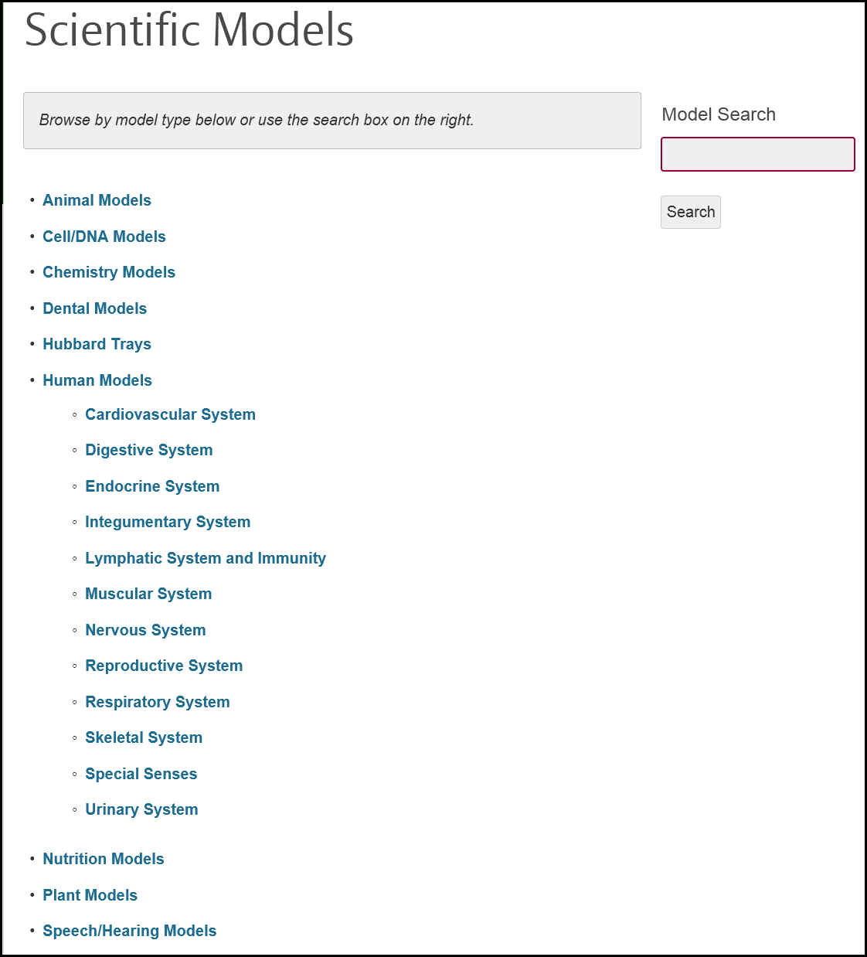
Scientific Models main search page and sample entry:

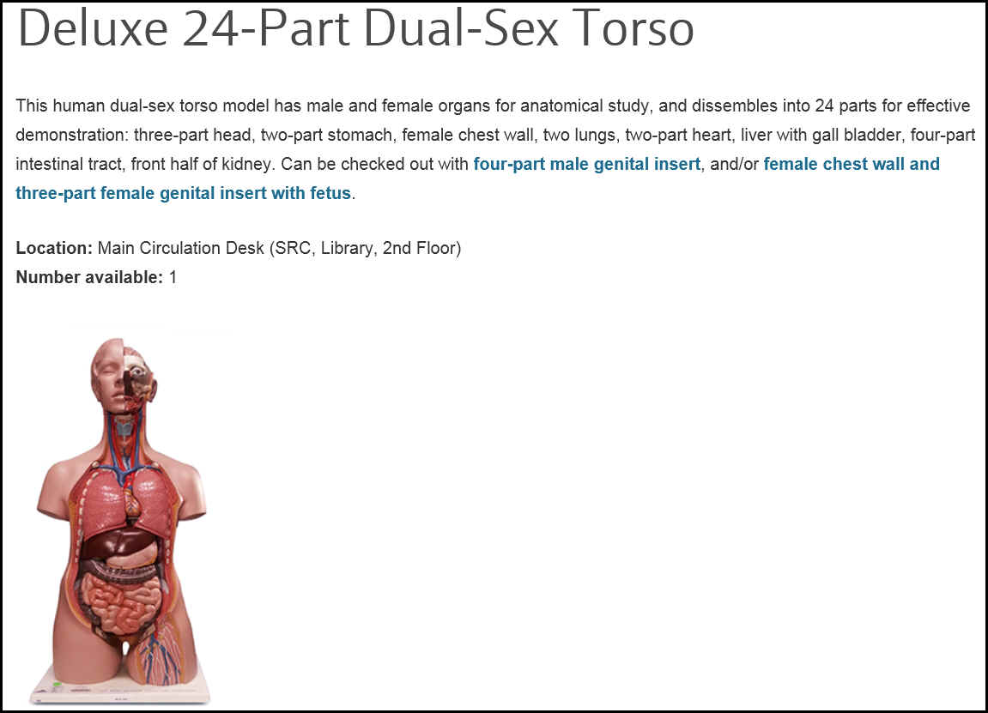
Sample model entry from the Muscular System category
Appendix B
College of DuPage Library
Nursing Scope and Standards of Practice Resources
Located at the Circulation Desk, under Course Reserves: NURSI: Nursing All Classes/Students

Addictions nursing: scope and standards of practice, 2013
Cardiovascular nursing: scope and standards of practice, 2008
Correctional Nursing: scope and standards of practice, 2013
Faith community nursing: scope and standards of practice, 2012
Forensic nursing: scope and standards of practice, 2009
Genetics/genomics nursing: scope and standards of practice, 2007
Gerontological nursing: scope and standards of practice, 2010
HIV/AIDS nursing: scope and standards of practice, 2007
Holistic nursing: scope and standards of practice, 2013
Home health nursing: scope and standards of practice, 2014
Intellectual and developmental disabilities nursing: scope and standards of practice, 2013
Legal nurse consulting: scope and standards of practice, 2006
Neonatal nursing: scope and standards of practice, 2013
Neuroscience nursing: scope and standards of practice, 2013
Nursing: scope and standards of practice, 2010
Nursing administration: scope and standards of practice, 2009
Nursing informatics: scope and standards of practice, 2015
Nursing professional development: scope and standards of practice, 2010
Pain management nursing: scope and standards of practice, 2005
Palliative nursing: scope and standards of practice: an essential resource for hospice and palliative nurses, 2014
Pediatric nursing: scope and standards of practice, 2008
Pediatric oncology nursing: scope and standards of practice, 2007
Perianesthesia nursing standards and practice recommendations, 2010
Plastic surgery nursing: scope and standards of practice, 2013
Psychiatric-mental health nursing: scope and standards of practice, 2014
Public health nursing: scope and standards of practice, 2013
Radiologic and imaging nursing: scope and standards of practice, 2013
Rheumatology nursing: scope and standards of practice, 2013
School nursing: scope and standards of practice, 2011
Scope and standards of diabetes nursing practice, 2003
Scope and standards of vascular nursing practice, 2004
Transplant nursing: scope and standards of practice, 2009

