Selected Resources for the
Diagnostic Medical Imaging Sonography (DMIS) Program
2019

The College of DuPage Library is located in the Student Resource Center. During the academic year, the Library is open 7 days a week at the following times:
Regular Hours:
Monday - Thursday |  | 7:30am - 10:00 pm
Friday |  | 7:30 am - 4:30 pm
Saturday |  | 9:00 am - 4:30 pm
Sunday |  | 12 noon - 6:00 pm

For a current listing of Library closings and adjusted operating hours (exam preparation extended hours or when classes are not in session), consult http://codlrc.org/hours

The Library Reference staff consists of 22 (10 full-time and 12 part-time) professional librarians and 11 reference assistants. The Library has a research appointment desk and a reference station located on the main level. Another reference station is located on the Library’s second level. A minimum of one librarian and one reference assistant are scheduled upstairs and down with additional staffing added during peak service hours.

The library liaison to faculty and students in the DMIS Program is Debra J. Kakuk Smith, Professor/Reference Librarian. Smith is an experienced instructor with 20+ years of experience as a medical librarian. For more information see https://cod.libguides.com/smith

Instruction and Reference Services

Students can access the COD Library’s resources 24 hours a day, 7 days a week via the Internet at the URL http://www.cod.edu/library. Students use their library card numbers to access electronic book, streaming video and journal article databases and to place holds, and I-Share and Interlibrary Loans (ILL).

Students receive reference assistance in person, by phone, email, or instant message during library operating hours. The electronic (email) reference service is called “Ask a Librarian.” “Ask a Librarian” questions are answered throughout open hours of operation and students can expect a reply to their questions within 24 hours of submission. Users may instant message Librarians during open hours of operation using AOL Instant Messenger, Yahoo!, MSN, Google Talk, or Jabber chat services. Students may directly contact particular librarians as well. Smith’s contact information is: Debra J. Kakuk Smith, SRC 3149, smithkak@cod.edu, (630) 942-4305.

From the Library homepage, students have the option of clicking on a button and scheduling a 30-minute research appointment with a COD Librarian. In addition to selecting a time convenient to students’ busy schedules, they can choose either a face-to-face appointment held in the Library a real-time, virtual reference appointment. Another button on the homepage allows students to “book” a group study room for individual or group study. Study rooms can also be reserved on a walk-up basis depending upon availability. Descriptions of group study rooms can be found at: https://www.codlrc.org/spaces/list

An online Diagnostic Medical Imaging Resource Guide (located at https://www.codlrc.org/hs/dmi) provides students and faculty with: catalog links, recommended reference materials in the College of DuPage Library collection, Internet sites (including associations, organizations, consumer/general information and reference sites), health information literacy information, and APA citation style tips. The materials range from those suitable for patient education to information geared to health science students and practicing professionals. The guide contains materials pertaining to students’ current studies as well as professional development resources. This research guide was created and is currently maintained with direct input from the Diagnostic Imaging Faculty.

Students have access to 100+ Gateway Workstations throughout the two floors of the main campus COD Library. In addition, wireless laptops with access to all library resources are available for student checkout and use within the library (including 17 small group rooms, a faculty seminar room and quiet study areas). The Library offers free wireless access for all users. The Library workstations and laptops have productivity software (Microsoft Office Suite and Adobe products) installed. A variety of printing options are available. Students can load interactive, educational software and check-out headphones at the circulation desks. The workstations have software that reinstalls an original build every time the workstations are shut down or restarted. Reference staff and computer support/print services staff are available to assist students with computer/technology-related questions.

A Digital Media Lab, http://codlrc.org/lab, is located in the Library’s lower level and is freely available to COD students. COD students can create and edit all kinds of digital audio, video, and images in the Lab that contains imaging stations and A-V editing suites. The Lab features high-powered Mac workstations and popular media production software like Adobe's Creative Cloud suite and Avid Pro Tools. Students can use high quality photo scanners, drawing tablets, a 3D scanner, DSLR cameras, microphones, and other audio peripherals. Dedicated Media Lab staff are available to assist students with every step of the media creation process. Media Lab staff also offer orientation sessions, workshops and tours to classes and individuals.

Faculty members are encouraged to schedule specialized library instruction and research assistance with the Health Science Division Librarian, Debra J. Kakuk Smith. Smith and Health Sciences faculty work together to create quality information literacy assignments that assist students in becoming lifelong learners. The library has five computer classrooms that include hands-on student workstations (accommodating 20-40 students) as well as instructor stations and digital projectors. In addition, on and off campus classroom visits and instruction sessions can be arranged.

Each semester, including summer, the library offers free workshops on a variety of academic and information literacy topics. Students may choose to attend in-person or online workshops on a wide-range of topics. Workshops are offered during the day, evenings and weekends. Students can view information about current workshop offerings at http://codlrc.org/sos

Journals, Periodicals and Streaming Video Database Offerings

The College of DuPage Library provides access to journals and periodicals in support of the DMIS curriculum. Through the COD Library Home Page (http://www.cod.edu/library/), DMIS students have 24 hour, 7 days a week access to the COD Library’s catalog and the article databases.

The College of DuPage Library subscribes to 117+ electronic databases and approximately 31,134 electronic books. Ebooks are accessed via the Library catalog or via the ebooks database page: https://www.codlrc.org/databases/ebooks DMIS students have access to numerous health and science related databases such as the Cumulative Index to Nursing and Allied Health Literature (CINAHL) Complete, HealthSource: Nursing/Academic and Consumer, Academic Search Complete (from EBSCO), ScienceDirect, Micromedex Health Care Series (including CareNotes), and PubMed. Full text access is also available to numerous journal articles expanding the Library’s print periodical holdings for students and faculty. See https://www.codlrc.org/databases/medicine

In addition to “traditional” periodical databases, the COD Library provides DMIS students with access to online full-text reference books using Gale Virtual Reference Center. Streaming Videos are also available from a variety of electronic video databases. Especially relevant to DMIS students are the Medical Imaging in Video and Academic Video Online databases that include all current Medcom Trainex videos. For descriptions of COD Library’s Online Video databases, go to: https://www.codlrc.org/databases/videos

DMIS Journals

The College of DuPage subscribes to 393 print periodicals. DMIS students have access to 141 online and print journals and magazines specific to medical imaging. Many other Health and Medicine-related titles are available. The most recent Library periodical holdings (electronic and print) are available in a conveniently arranged subject list at:
Health & Biological Sciences: Medicine: Radiology, MRI, Ultrasonography & Medical Physics http://sc9jf5ze6e.search.serialssolutions.com/?V=1.0&L=SC9JF5ZE6E&N=100&SS_searchTypeAll=yes&S=SC&C=HE0338

Interlibrary Loan (ILL) & I-SHARE

Students enrolled in the DMIS Program have 24-hour access to our Interlibrary Loan (ILL) Department. On and off campus, students and faculty can search and submit online requests for articles, book chapters and books. The College of DuPage has online access to thousands of local, national and world-wide Online Computer Library Center (OCLC) Libraries. Using the Ariel Document Delivery System, our interlibrary loan department requests, receives and delivers documents to our faculty and students via email.

In addition to traditional ILL, students and faculty have access to I-Share borrowing. When searching COD’s catalog, Illinois holdings (including over 14.7 million unique bibliographic records and more than 38 million item records, representing the holdings of 90 CARLI I-Share member institutions) as well as international OCLC holdings appear. COD library users can request books from these participating Illinois libraries using their free I-Share accounts. While traditional ILL requests can take 5-10 days to arrive, I-Share requests typically arrive in 2-5 days.

Students and faculty may pick up their materials at the College of DuPage Library. Returned items can be mailed, or dropped off at convenient College of DuPage book drops located on the main campus as well as the Regional Centers in Westmont, Addison and Naperville, Illinois.

Print Collection

COD Library holdings in DMIS and related disciplines provide a broad range of materials that are relevant to the curriculum. Students with the desire to do more research in the medical areas have access to over 9,500 medical-related books, audiovisuals and software programs. New library materials (including journals, books, software, models, and DVDs) are added to the collection on an ongoing basis. Acquisitions are based on the recommendations of program faculty and the recommendations of the division librarian, Debra J. Kakuk Smith, who develops the collection and manages its budget. Ms. Kakuk Smith utilizes the Doody’s Core Titles in the Health Sciences list as well as other medical review resources to assist in ordering materials. The opinions and suggestions of program faculty regarding the current collection and possible new resources are solicited throughout the academic year. The division librarian coordinates weeding (deletion) of out-of-date materials with input from the program faculty. A current, Excel file of core materials specific to the DMIS program is available on the Diagnostic Imaging resource guide main page (for viewing or download): https://www.codlrc.org/hs/dmi

College and Career Information Center

The College and Career Information Center (CCIC), located on the second floor of the library, provides a multimedia collection of information on educational opportunities, occupational choices, and job-seeking skills. Special databases are available to help in choosing an appropriate college or career. Reference staff assist users in this area and online assistance is available at http://codlrc.org/ccic. Examples of DMIS materials in the CCIC collection include licensure exam preparation review books; career guides for DMIS program graduates (videos as well as books); information on other academic institutions and admission tests/requirements; resume and interview materials for health care professionals.

Science Material and “Hands-On” Resources

In addition to the core DMIS program materials, the COD Library has an extensive collection of basic science material including: embryology, anatomy, physiology, chemistry, pharmacology, and microbiology. Students may also check out microscope slides, bones, anatomical models (See Appendix A), interactive software programs and other resources for hands-on experience and review. These items are physically housed at the Library’s Main-Floor Circulation Desk.

Audiovisual Materials

A variety of videos (VHS and DVD formats) and DVD ROM or CD ROM titles are contained in the College of DuPage library collection. For descriptions of COD Library’s Online Video databases, go to: https://www.codlrc.org/databases/videos. Additional audio visual (and print) resources also are available in the collection on topics such as human anatomy and physiology, Universal Precautions, HIPAA regulations, transcultural medical delivery, medical ethical and legal issues and other topics pertinent to health care students, faculty and professionals. Program faculty routinely provide provide feedback on the usefulness and accuracy of audiovisual materials prior to the Library purchasing the items. Program faculty also review current Library holdings to ensure clinical accuracy of content.

Individual video monitors, CD/DVD players as well as computer workstations are available on the first floor of the library for student and faculty use. The Library has an audiovisual distribution center that delivers equipment to classrooms. The Library’s faculty “booking” system allows instructors to reserve and pick-up AV materials for classroom viewing. Audiovisual materials and equipment can also be delivered to off-campus classrooms and regional centers.
Circulation Services

Faculty place specific materials on reserve at the Circulation Desk for students. Reserve materials ensure that all students will have access to reference materials or other high-demand items. The reserve collection contains anatomical models for use within the library. A Diagnostic Imaging Special Reserves collection is located on a cart at the Upstairs (3rd floor) Reference Desk. See https://www.codlrc.org/HS/dmi/reserves

Appendix A
College of DuPage
Library Anatomical Models Database
The library has a large collection of models that can be checked out for student use at the Main Circulation Desk of the Library. An updated list of Anatomy Models arranged by type is available in the Models database at: http://codlrc.org/models. Browse by type of model or search by a specific model (AKA "stomach"). Individual model pages include detailed descriptions, images, links to related models, location and availability.
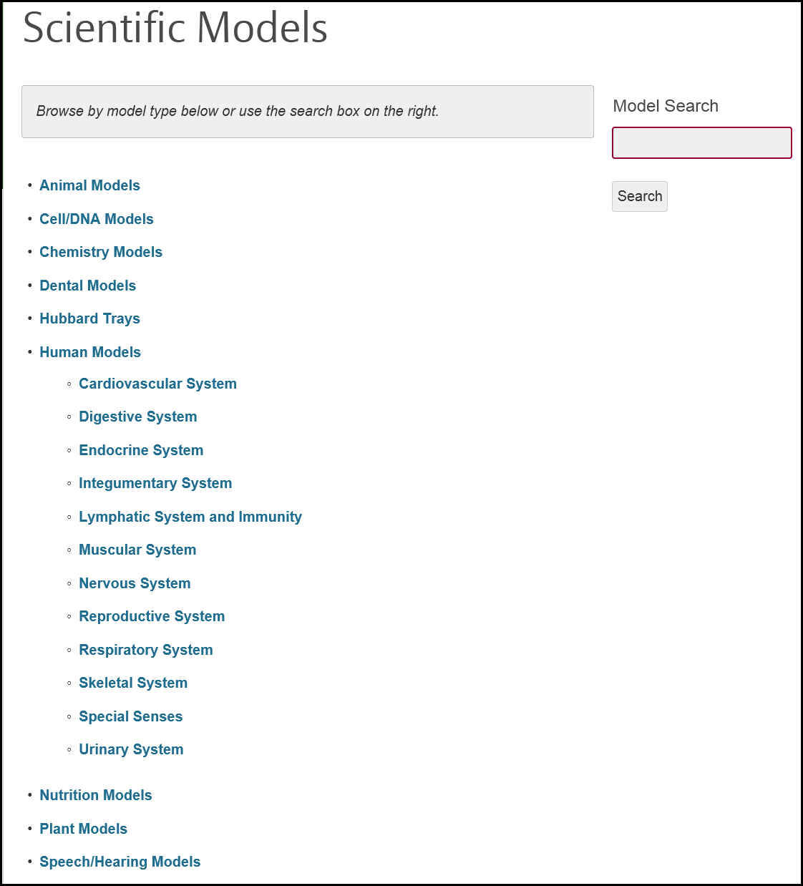Scientific Models main search page and sample entry:

Sample model entry from the Muscular System category

