Selected Resources for the
Eye Care Assistant Program
2018

The College of DuPage Library is located in the Student Resource Center. During the academic year, the Library is open 7 days a week at the following times:
Regular Hours:
Monday - Thursday | 7:30am - 10:00 pm
Friday | 7:30 am - 4:30 pm
Saturday | 9:00 am - 4:30 pm
Sunday | 12 noon - 6:00 pm

For a current listing of holiday Library closings and adjusted vacation operating hours (when classes are not in session), consult http://codlrc.org/hours.

The Library Reference staff consists of 22 (10 full-time and 12 part-time) professional librarians and 11 reference assistants. The Library has two reference stations located on the main level and a third reference desk located on the Library’s second level. A minimum of one librarian and one reference assistant are scheduled upstairs and down with additional staffing added during peak service hours.

The library liaison to faculty and students in the Eye Care Assistant Program is Debra J. Kakuk Smith, Professor, Reference Librarian. Smith is an experienced instructor and medical librarian. For more information see http://codlrc.org/smith

Instruction and Reference Services

Students can access the C.O.D. Library’s resources 24 hours a day, 7 days a week via the Internet at the URL http://www.cod.edu/library. Students must use their library card barcode numbers to access electronic databases and to place holds, I-Share and Interlibrary Loans (ILL).

Students receive reference assistance in person, by phone, email, or instant message during library operating hours. The electronic (email) reference service is called “Ask a Librarian.” “Ask a Librarian” questions are answered throughout open hours of operation and students can expect a reply to their questions within 24 hours of submission. Users may instant message Librarians during open hours of operation using AOL Instant Messenger, Yahoo!, MSN, Google Talk, or Jabber chat services. Via a button on the Library homepage, students can schedule convenient 30-minute research appointments with reference librarians. Students may directly contact specific librarians for research assistance. Smith’s contact information is: Debra J. Kakuk Smith, SRC 3149, smithkak@cod.edu, (630) 942-4305.

An online Eye Care Assistant Resource Guide located at https://www.codlrc.org/hs/eye provides students and faculty with: catalog links, recommended reference materials in the College of DuPage Library collection, Internet sites (including associations, organizations, consumer/general information and reference sites), health information literacy information, and APA citation style tips. The materials range from those suitable for patient education to information geared to health science students and practicing professionals. The guide contains materials pertaining to their current studies as well as professional development resources. This research guide was created and is currently maintained with direct input from Eye Care Assistant Program Faculty.

Students have access to 100+ Gateway Workstations throughout the two floors of the main campus COD Library. In addition, wireless laptops with access to all library resources are available for student checkout and use within the library (including small group rooms and quiet study areas). The Library offers free wireless access for all users. The Library workstations and laptops have productivity software (Microsoft Office Suite and Adobe products) installed on them and a variety of printing options are available. Students can also load interactive, educational software and check-out headphones at the circulation desk. The workstations have software that reinstalls an original build every time the workstations are shut down or restarted. Reference librarians and computer support/print services staff are available to assist students with computer/technology-related questions.

Recognizing the collaborative nature of our academic programs, the COD Library offers a variety of technology-equipped, group study rooms (accommodating anywhere from 2-12 students). See https://www.codlrc.org/spaces/list for detailed information on each room (including images). Students can book study rooms in advance using our convenient booking system linked from the Library’s homepage.

A Digital Media Lab, http://codlrc.org/lab, is located in the Library’s lower level and is freely available to COD Library card holders. COD students can create and edit all kinds of digital audio, video, and images in the Lab containing four imaging stations and two separate A-V editing suites. The Lab features high-powered Mac workstations and popular media production software like Adobe's Creative Cloud suite and Avid Pro Tools. Students can use high quality photo scanners, drawing tablets, a 3D scanner, DSLR cameras, microphones, and other audio peripherals.

Faculty members are encouraged to schedule specialized library instruction and research assistance with the Health Science Division Librarian, Debra J. Kakuk Smith. The Library and Health Sciences faculty work together to create quality information literacy assignments that assist students in becoming lifelong learners. The library has six technical classrooms, including hands-on computer labs equipped with enough workstations for 20-40 students as well as an instructor station and digital projector. An additional library classroom is available with an instructor workstation, digital projector and three-dimensional document reader for demonstration classes. On and off campus classroom visits and instruction sessions can be arranged by contacting Debra J. Kakuk Smith.

Each semester of the academic year, including summer, the library offers free workshops on a variety of academic and information literacy topics. Students may choose to attend in-person or online workshops on a wide-range of topics such as Introduction to the Library, Research Strategies, APA Documentation, Consumer Health, Job Seeking, Internet Basics and Advanced Online Search Strategies. Classes are offered during the day, evenings and weekends. Students can view information about current workshop offerings at http://codlrc.org/sos

Journals, Periodicals and Online Database Offerings

The College of DuPage Library provides access to journals and periodicals in support of the Eye Care Assistant curriculum. Students in the program have access to periodicals through electronic databases. Through the College of DuPage Library Home Page (http://www.cod.edu/library/), Eye Care Assistant students have 24 hour, 7 days a week access to the College of DuPage Library catalog and the article databases.

The College of DuPage Library subscribes to 140+ electronic databases and approximately 54,583 electronic books. Eye Care Assistant students have access to numerous health and science related databases such as the Cumulative Index to Nursing and Allied Health Literature (CINAHL) Complete, Gale’s Academic OneFile, HealthSource: Nursing/Academic and Consumer, Academic Search Complete (from EBSCO), ScienceDirect, Micromedex Health Care Series (including CareNotes), and MEDLINE. Full text access is also available to numerous journal articles on line which expands the library’s print periodical holdings for students and faculty. See https://www.codlrc.org/databases/medicine

In addition to “traditional” periodical databases, the C.O.D. Library provides Eye Care Assistant students with access to ADAM Interactive Physiology (Networked version), full-text reference book access using The Gale Virtual Reference Center, and test preparation materials available in the Learning Express Library. Streaming Videos are also available from a variety of electronic video databases. For descriptions of COD Library’s Online Video databases, go to: https://www.codlrc.org/databases/videos

Eye Care Assistant Journals

The College of DuPage subscribes to 385 print periodicals. Eye Care Assistant students have access to a wide variety of medical and health sciences journals and magazines including 90 Ophthalmology & Optometry journals and magazines. The most recent Library periodical holdings (online and in print) are available for perusal online in a conveniently arranged subject list at: http://sc9jf5ze6e.search.serialssolutions.com/?C=HE&V=1.0&L=SC9JF5ZE6E&S=SC
The list of Ophthalmology & Optometry journals and magazines is located at:
http://sc9jf5ze6e.search.serialssolutions.com/?V=1.0&L=SC9JF5ZE6E&N=100&SS_searchTypeAll=yes&S=SC&C=HE0333

Interlibrary Loan (ILL) & I-SHARE

Students enrolled in the Eye Care Assistant Program have 24-hour access to our Interlibrary Loan (ILL) Department. Students and faculty are able to search and submit their requests for journal and periodical articles, book chapters and books electronically from COD workstations or at home. The College of DuPage has online access to thousands of Online Computer Library Center (OCLC) Libraries in our local area and around the world. These libraries provide our students and staff with access to millions of items that are not available in our collection. The Ariel Document Delivery System allows our interlibrary loan department to request and receive student interlibrary loan materials electronically from locations worldwide. Documents received through Ariel can also be emailed directly to students and faculty.

In addition to traditional ILL, students and faculty now have access to I-Share borrowing. When searching COD’s catalog, Illinois holdings (including over 14.7 million unique bibliographic records and more than 38 million item records, representing the holdings of 90 Illinois College and Research Library I-Share member institutions) as well as international OCLC holdings appear. COD library users can request books from these participating Illinois libraries using their free I-Share accounts. While traditional ILL requests can take 5-10 days to arrive, I-Share requests typically arrive in 2-5 days.

Students and faculty may pick up their materials at the College of DuPage Library for free. For materials that must be returned, items can be mailed, or dropped off at convenient College of DuPage book drops located on the main campus as well as the Regional Centers in Westmont, Addison and Naperville, Illinois.

Students can request assistance with the use of journals and periodicals via the “Ask a Librarian” online reference service (email), via phone, or in person.

Print Collection

COD Library holdings in Eye Care Assistant and related disciplines provide a broad range of materials that are relevant to the curriculum. Students with the desire to do more research in the medical areas have access to over 9,500 medical-related books, audiovisuals and software programs. New library materials are added to the collection on an ongoing basis. Acquisitions are based on the recommendations of program faculty and the recommendations of the division librarian, Debra J. Kakuk Smith, who develops the collection and manages its budget. Ms. Kakuk Smith utilizes the Doody’s Core Titles in the Health Sciences list, The Medical Library Association’s Master Guide to Authoritative Information Resources in the Health Sciences, as well as other medical review resources to assist in ordering materials. The opinions and suggestions of program faculty regarding the current collection and possible new resources are solicited throughout the academic year. The division librarian coordinates weeding (deletion) of out-of-date materials with input from the program faculty. A current list of select print and e-books specific to the Eye Care Assistant program (see Appendix B) is available on the Eye Care Assistant Resource guide (for viewing or download): https://www.codlrc.org/hs/eye/books

College and Career Information Center

The College and Career Information Center (CCIC), located on the second floor of the library, provides a multimedia collection of information on educational opportunities, occupational choices, and job-seeking skills. Special databases are available to help in choosing an appropriate college or career. Reference staff members assist users in this area and online assistance is available at http://codlrc.org/ccic. Examples of Eye Care Assistant materials in the CCIC collection include licensure exam preparation review books; career guides for Eye Care Assistant program graduates (videos as well as books); information on other academic institutions and admission tests/requirements; resumé and interview materials for health care careers and Internet sites for Eye Care Assistant-related organizations and associations.

Science Material and “Hands-On” Resources

In addition to the core Eye Care Assistant program materials, the COD Library has an extensive collection of basic science material including: anatomy, physiology, chemistry, pharmacology, and microbiology. Students may also check out microscope slides, bones, anatomical models (See Appendix A), interactive software programs and other resources for hands-on experience and review. These items are physically housed at the Library’s Main-Floor Circulation Desk.

Audiovisual Materials

A variety of videos (VHS and DVD formats) and DVD ROM or CD ROM titles are contained in the College of DuPage library collection. Streaming Videos are available from a variety of electronic video databases. For descriptions of COD Library’s Online Video databases, go to: https://www.codlrc.org/databases/videos. Additional audio visual (and print) resources also are available in the collection on topics such as human anatomy and physiology, Universal Precautions, HIPAA regulations, transcultural medical delivery, medical ethical and legal issues and other topics pertinent to health care students, faculty and professionals. Program faculty often preview and provide feedback on the usefulness and accuracy of audiovisual materials (DVDs, VHS, CD-ROMs) prior to the Library purchasing the items. Program faculty review Library holdings to ensure clinical accuracy of content.

Individual video monitors, cassette and CD/DVD players as well as computer workstations are available on the first floor of the library for student and faculty use. The Library has an audiovisual distribution center that delivers equipment to classrooms throughout the main campus and the west campus. The Library’s faculty “booking” system allows instructors to reserve and pick-up AV materials for classroom viewing. Audiovisual materials and equipment can also be delivered to off-campus classrooms and regional centers.

Circulation Services

Faculty may place specific materials on reserve at the Circulation Desk for students. Reserve materials ensure that all students will have access to reference materials or other high-demand items. The reserve collection contains anatomical models for use within the library.

Students are able to place materials on hold by phone or online by accessing the library’s Web site. Students may pick up hold materials at the circulation desk. Students may return items by mail or drop them off at convenient College of DuPage book drops located on the main campus as well as the Regional Centers in Westmont, Addison and Naperville, Illinois.
Appendix A
College of DuPage Library
Anatomical Models

The library has a large collection of models that can be checked out for student use at the Main Circulation Desk of the Library. An updated list of Anatomy Models arranged by type is available at: http://codlrc.org/models. Browse by type of model or search by a specific model (AKA "stomach"). Individual model pages include detailed descriptions, a digital image, links to related models, location and availability.
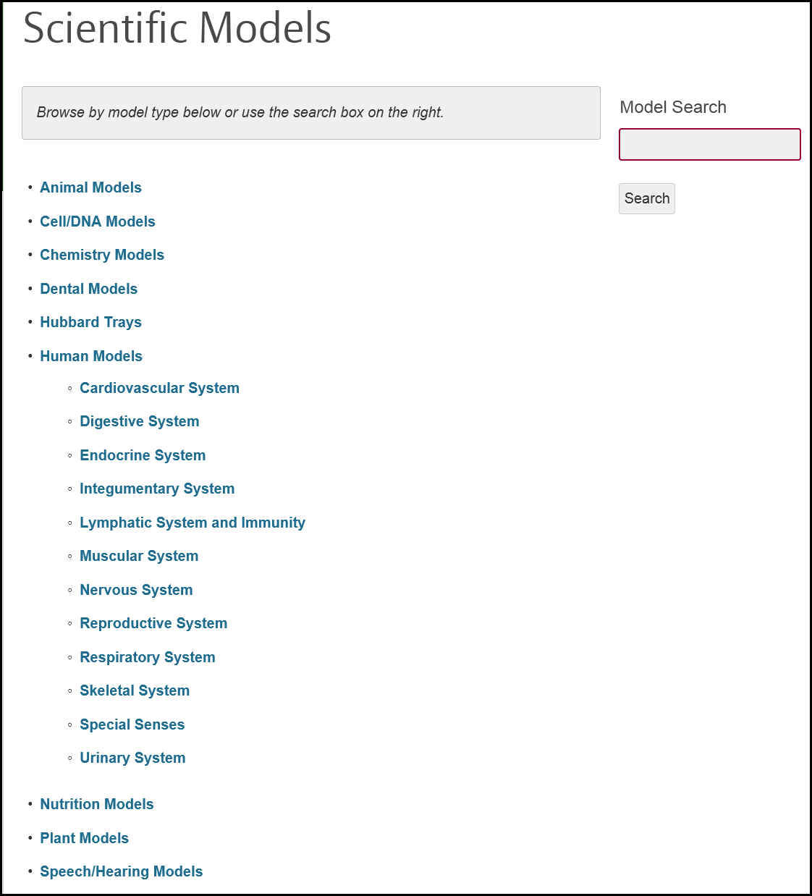Scientific Models main search page and sample entry:

Appendix B
Sample model entry from the Muscular System category
Select Eye Care Specific COD Library Resources 2018

AMA guides to the evaluation of ophthalmic impairment and disability : measuring the impact of visual impairment on activities of daily life
by Bernard R. Blais, American Medical Association.
eBook
Publication: Chicago : American Medical Association, ©2011.
ISBN: 9781603597647 1603597646
- Ebook available via the Library Catalog
Ocular anatomy and physiology
by Al. Lens, Sheila Coyne. Nemeth, Janice K. Ledford
Print book
Publication: Thorofare, NJ : SLACK, ©2008.
ISBN: 9781556427923 1556427921
Call Numbers:
- QP475 .O28 2008 - General Collection
Clinical optics primer for ophthalmic medical personnel : a guide to laws, formulae, calculations, and clinical applications
by Aaron V. Shukla
Print book
Publication: Thorofare, NJ : SLACK Inc., ©2009.
ISBN: 9781556428999 1556428995
Call Numbers:
- QP475 .S555 2009 - General Collection
Vision : how it works and what can go wrong
by John E. Dowling, Joseph L. Dowling Jr.
Print book
Publication: Cambridge, Massachusetts : The MIT Press, [2016]
ISBN: 9780262034616 0262034611 9780262333566 0262333562
- QP475.5 .D69 2016 --General
Ophthalmic dictionary and vocabulary builder for eye care professionals
by Harold A. Stein, Raymond M. Stein
Print book
Publication: New Delhi : Jaypee Brothers Medical, 2012.
ISBN: 9789350253656 9350253658
Call Numbers:
- RE20 .S73 2012 - General Collection

Dictionary of eye terminology
by Barbara Cassin, Melvin L. Rubin
Print book
Publication: Gainesville, Florida. : Triad Publishing Company, 2012.
ISBN: 9780937404737 093740473X
Call Numbers:
- RE21 .C37 2012 - General Collection
Adler's physiology of the eye.
by Leonard A. Levin, Francis Heed Adler
Print book
Publication: Edingburg : Saunders/Elsevier, ©2011.
ISBN: 9780323057141 0323057144
Call Numbers:
- RE67 .A32 2011 - Circulation Desk Books
Eye pathology : an atlas and text
by Ralph C. Eagle Jr.,
Print book
Publication: Philadelphia : Wolters Kluwer, [2017]
ISBN: 9781496337177 1496337174
Call Numbers:

- RE67 .E24 2017 - General Collection

Clinical skills for the ophthalmic examination : basic procedures
by Lindy DuBois
Print book
Publication: Thorofare, NJ : SLACK Inc., ©2006.
ISBN: 9781556427497 1556427492
Call Numbers:
- RE72.5 .D83 2006 - General Collection
Certified ophthalmic assistant exam review manual
by Janice K. Ledford
Print book
Publication: Thorofare, NJ : SLACK, ©2012.
ISBN: 9781617110580 1617110582
Call Numbers:
- RE72.5 .L43 2012 - Career & College Information Center

Ophthalmic assistant : a text for allied and associated ophthalmic personnel
by Harold A. Stein, Raymond M. Stein, Melvin I. Freeman
Print book
Publication: [New York] : Elsevier, [2018]
ISBN: 9780323394772 0323394779
Call Number:

- RE72.5 .S84 2018 - General Collection

Care and handling of ophthalmic microsurgical instruments
by American Society of Ophthalmic Registered Nurses.
Print book ©2011
Publication: [San Francisco, CA] : American Society of Ophthalmic Registered Nurses ; Dubuque, Iowa : Kendall/Hunt Publishing, ©2011.
ISBN: 9780982895412 0982895410
- RE73 .C374 2011 – General Collection
Visual fields via the visual pathway
by Fiona J. Rowe
Print book
Publication: Boca Raton : CRC Press, Taylor & Francis Group, [2016]
ISBN: 9781482299632 1482299631
Call Numbers:
- RE79.P4 R69 2016 - Circulation Desk Books
Visual fields : examination and interpretation
by Thomas J. Walsh
Print book
Publication: New York : Oxford University Press, 2011.
ISBN: 9780195389685 0195389689
Call Numbers:
- RE79.P4 V58 2011 - Circulation Desk Books
Ophthalmic medications and pharmacology
by Brian Duvall, Robert M. Kershner
Print book
Publication: Thorofare, NJ : SLACK Inc., ©2006.
ISBN: 1556427506 9781556427503
Call Numbers:
- RE994 .D88 2006 - General Collection

