Making the Most of Micromedex
www.cod.edu/library Databases tab Databases by Title tabMicromedex Healthcare Series
Drug Information
The Library contains multiple print drug handbooks, manuals and resources (see books, videos & models section of the Nursing guide) and the Websites section of the guide links to various Internet (freely available) sites. However, your BEST BET and most credible resource is the point-of-care clinical database, Micromedex.
Micromedex Health Care Series
**Access from on campus is automatic. Access from off campus requires last name and library barcode** The “Download Mobile Apps” link contains passwords for free downloads—check COD’s Micromedex download page FREQUENTLY as passwords change often with updates!
- MICROMEDEX provides full-text clinical information including: drug monographs and evaluations, drug dosages and interactions, drug product identification, reproductive risks, toxicity management, alternative medicine/herbal preparations information, acute/emergency care guidelines, drug, disease and condition information for patients, laboratory test information, dosage calculators, IV compatibility, nomograms, and references.
** Micromedex has FREE mobile apps for Apple, Android & Windows 8 devices**
For more information go to: http://www.codlrc.org/HS/mobilemicromedex
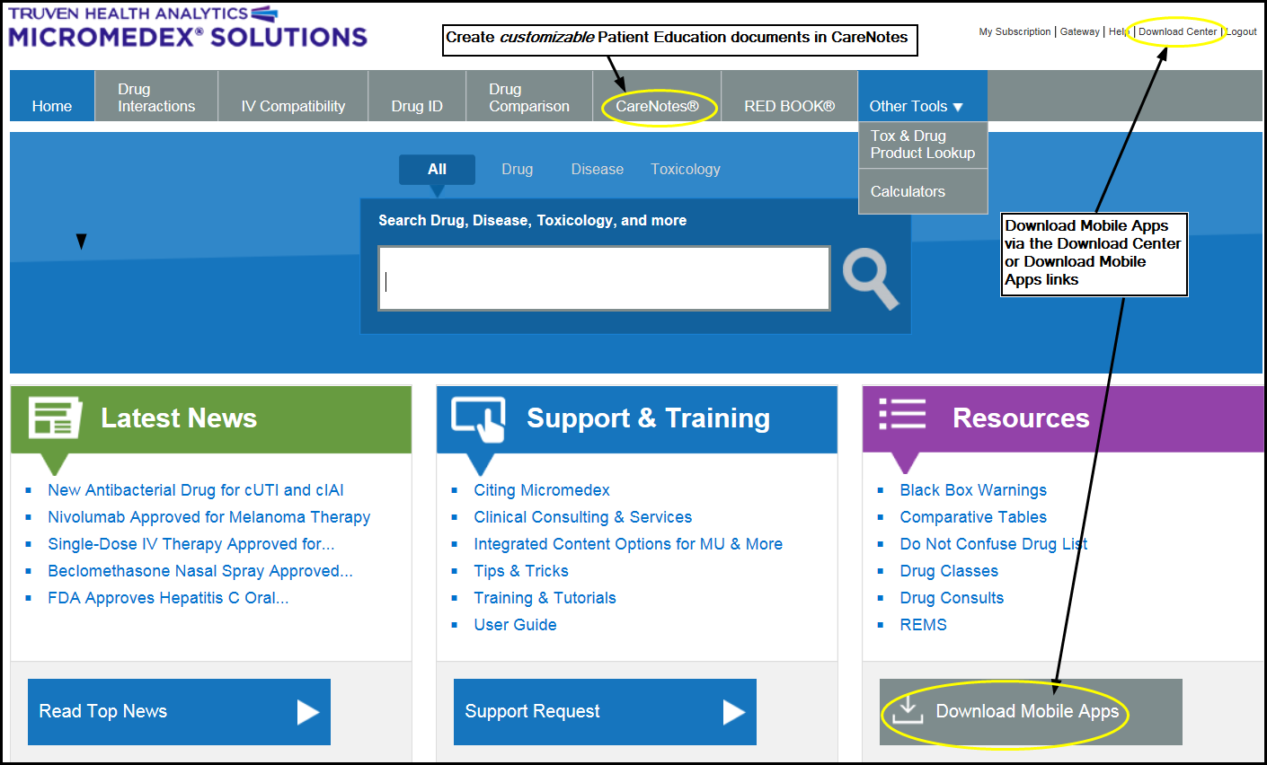
Customizable Patient Education
CareNotes (available from within Micromedex)
- CareNotes documents provide easy-to-understand information about all aspects of care and health. Presented in English and Spanish (and up to 13 other languages), the System's concise, customizable materials address patient condition, treatment, laboratory tests, follow-up care, psychosocial issues, continuing health, and the most frequently administered drugs. CareNotes information also helps meet JCAHO patient education guidelines.

