0
Making the Most of Micromedex
www.cod.edu/library Databases tab Databases by Title tabMicromedex Healthcare Series
The Library contains multiple print drug handbooks, manuals and resources (see books, videos & models section of the Nursing guide) and the Websites section of the guide links to various Internet (freely available) sites.
Your BEST BET and most credible drug resource is the point-of-care clinical database, Micromedex.
Micromedex Health Care Series
**Access from on campus is automatic. Access from off campus requires last name and library barcode** The “Download Mobile Apps” link contains passwords for free downloads—check COD’s Micromedex download page FREQUENTLY as passwords change often with updates!
- Micromedex is one of the largest online reference databases about drug information, toxicology, diseases, acute care and alternative medicine. This comprehensive resource provides healthcare professionals with clinical decision support for informed treatment decisions. Micromedex facilitates decision making in the areas of drug information, disease and condition management, toxicology and alternative medicine. It even addresses specific questions, such as IV compatibility and provides lab information to help choose appropriate tests and interpret results.
** Micromedex has FREE mobile apps for Apple & Android devices**
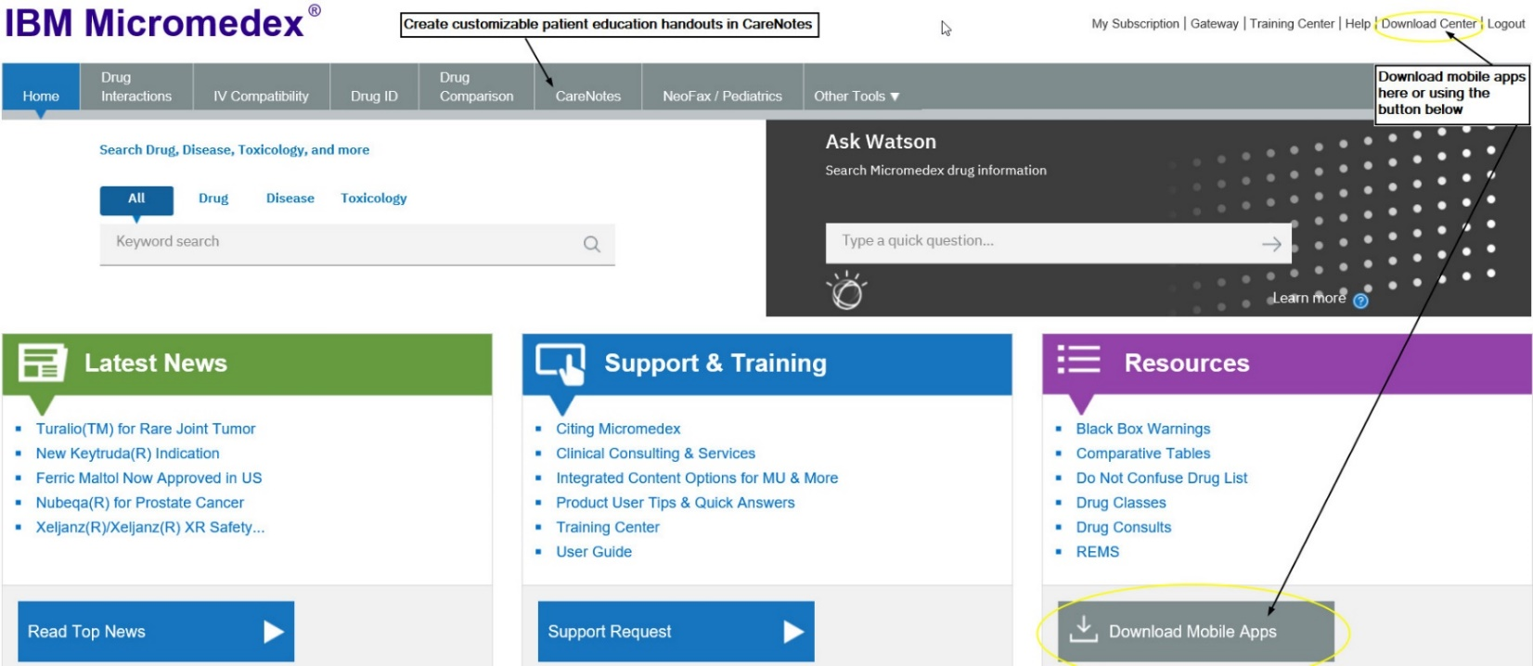
Customizable Patient Education
CareNotes (available from within Micromedex)
- CareNotes documents provide easy-to-understand information about all aspects of care and health. Presented in English and Spanish (and up to 13 other languages), the System's concise, customizable materials address patient condition, treatment, laboratory tests, follow-up care, psychosocial issues, continuing health, and the most frequently administered drugs. CareNotes information also helps meet JCAHO patient education guidelines.

