Nursing
Library Experience

Get to know the COD Library and HS Librarian. We are here to help you:

- Identify the different types of professional nursing information available
- Learn how information is tailored to meet the needs of diverse users (adults, children, parents, teachers, health professionals, health consumers)
- Determine which resources best answer different types of questions
- Search for medical information in C.O.D.’s online catalog, and article databases
- Understand using subjects (controlled vocabulary) in addition to formulating keyword searches to find evidence-based information
- Learn where to go and how to search for quality medical information using Micromedex, CINAHL, and other health-specific resources
- Evaluate the credibility of health information
- Create APA citations for your nursing projects and assignments

Accessing the COD Library Website is easy! www.cod.edu/library
Nursing Resource Guide: http://www.codlrc.org/hs/nursing
- Click the Library link at the bottom of the main cod.edu Web page
- Type “library” into the search box on the cod.edu main page
- Select “Library” from the cod.edu A-Z index (bottom of the page)
- Type “College of DuPage Library” into your favorite search engine
- The Library is linked from all your Blackboard courses!
Get your Library card!
- Gain 24/7 access to full-text, electronic health books, videos and article databases
- Check out videos, books, software, & anatomical models
- Reserve small group study rooms or schedule a research appointment
- Place FREE book and article I-Share or Interlibrary Loans (ILL) if the Library does not have what you need
- Remember, Library cards are FREE for C.O.D. students and community members!
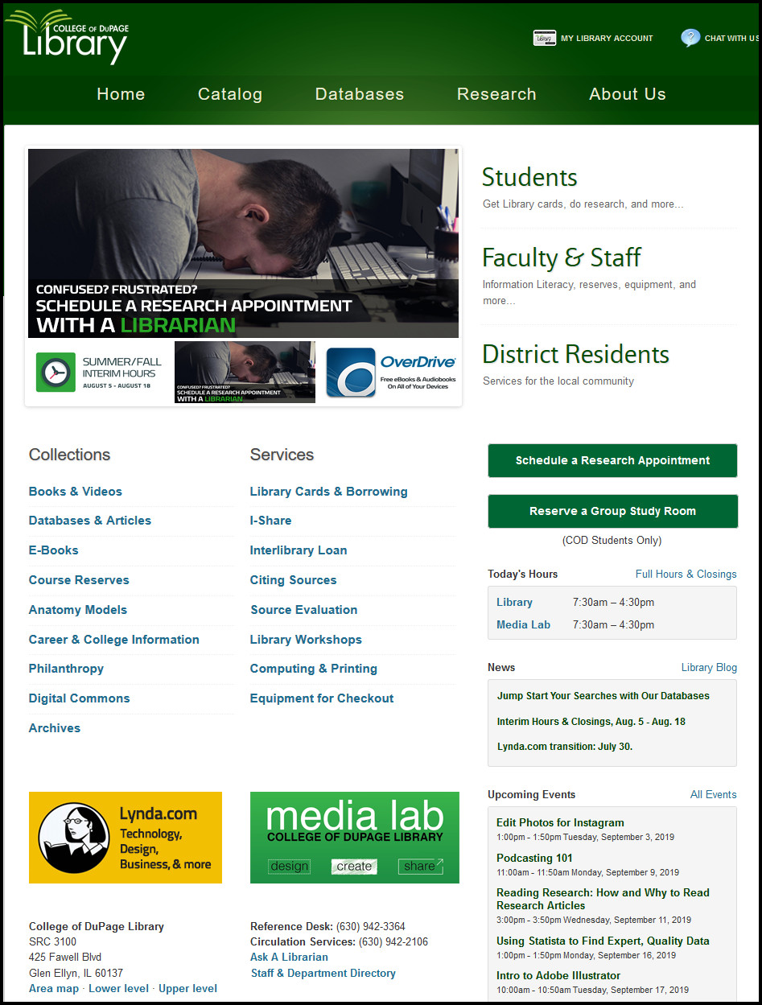
AWESOME Library Resources
www.cod.edu/library
Access the Nursing Guide via the Research tab

www.cod.edu/library Research (green tab) Nursing (ADN, BNA, PN)
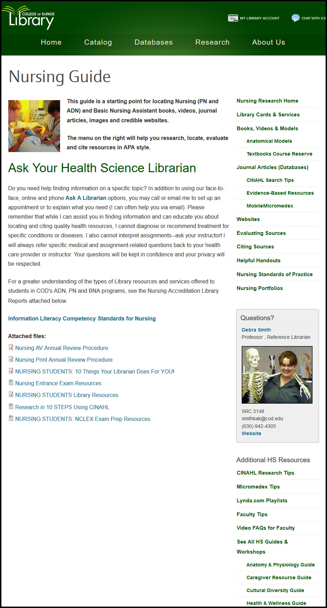
Drug info.
APA
Print textbooks
Research here
Drug Information
The Library contains multiple print drug handbooks, manuals and resources (see books, videos & models section of the Nursing guide) and the Websites section of the guide links to various Internet (freely available) sites.
Your BEST BET and most credible drug resource is the point-of-care clinical database, Micromedex.
Micromedex Health Care Series
**Access from on campus is automatic. Access from off campus requires last name and library barcode** The “Download Mobile Apps” link contains passwords for free downloads—check COD’s Micromedex download page FREQUENTLY as passwords change often with updates!
- Micromedex is one of the largest online reference databases about drug information, toxicology, diseases, acute care and alternative medicine. This comprehensive resource provides healthcare professionals with clinical decision support for informed treatment decisions. Micromedex facilitates decision making in the areas of drug information, disease and condition management, toxicology and alternative medicine. It even addresses specific questions, such as IV compatibility and provides lab information to help choose appropriate tests and interpret results.
** Micromedex has FREE mobile apps for Apple & Android devices**
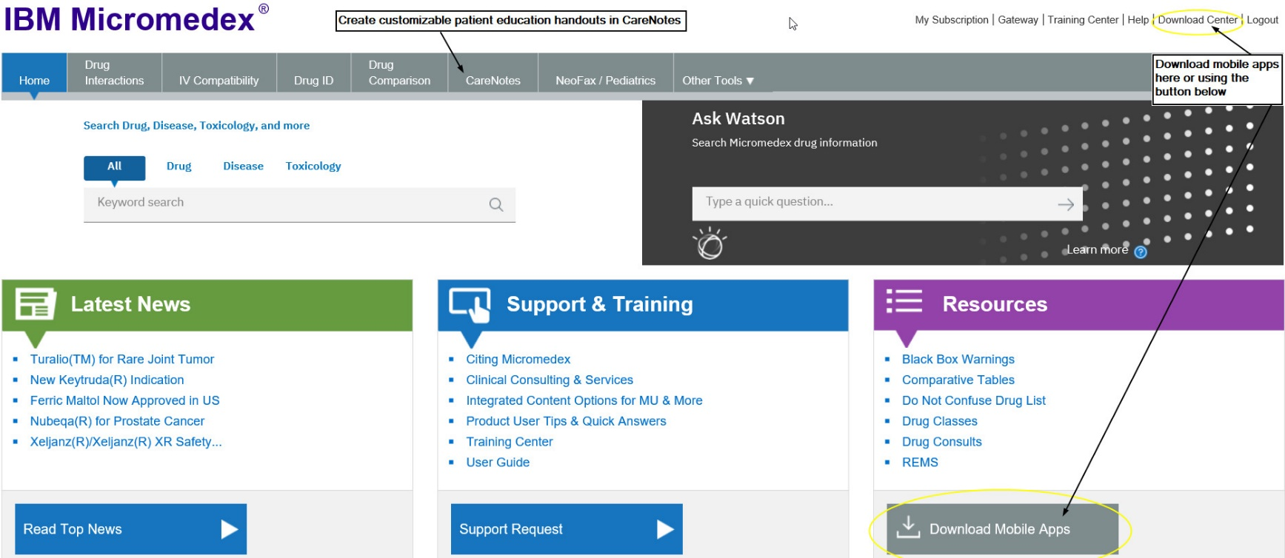

Customizable Patient Education Resources
CareNotes (available from within Micromedex)
- CareNotes documents provide easy-to-understand information about all aspects of care and health. Presented in English and Spanish (and up to 13 other languages), the System's concise, customizable materials address patient condition, treatment, laboratory tests, follow-up care, psychosocial issues, continuing health, and the most frequently administered drugs. CareNotes information also helps meet JCAHO patient education guidelines.
LOCATING NURSING ARTICLES & CLINICAL RESEARCH
Your BEST BET database for locating Nursing journal articles is CINAHL Complete.
- The Cumulative Index to Nursing & Allied Health Literature, (CINAHL) covers nursing, allied health, biomedical and consumer health journals, publications of the American Nursing Association, and the National League for Nursing. It includes the CINAHL Thesaurus and full text of over 1300 important nursing and clinical journals plus Evidence-based Care Sheets; Quick Lessons providing Overviews of Disease and Conditions; AND Continuing Education [CEUs].
**The full text and additional content (evidence-based care sheets, “quick lessons”, increased CE material AND research instrument records) are fabulous for nursing students in both classroom and clinical settings.
**See the CINAHL Search Tips link under Journal Articles (Databases) on the right-hand Nursing Guide navigation menu for definitions and step-by-step search help**
Need articles from Nursing journals for your course assignments? Follow the directions in the Research in 10 STEPS Using CINAHL handout!
APA CITATION AND DOCUMENT FORMATTING ASSISTANCE
Click on the Citing Sources link on the right-hand Nursing guide navigation menu
If you take ONE thing away from this handout, let it be this:
You are NOT alone. Help is available—all you have to do is ASK @ the COD Library!
Professor Debra J. Kakuk Smith
Office: SRC 3149 (Upper Level, Library)
Email: smithkak@cod.edu
Phone: 630 942-4305

Your “Personal Librarian”

