Nursing Orientation Library Overview & Services
Welcome to the Nursing program! Today’s session will introduce you to how the COD Library and HS Librarian will help you become a successful nurse.

Accessing the COD Library Website is easy! library.cod.edu/
Nursing Resource Guide: http://www.codlrc.org/hs/nursing
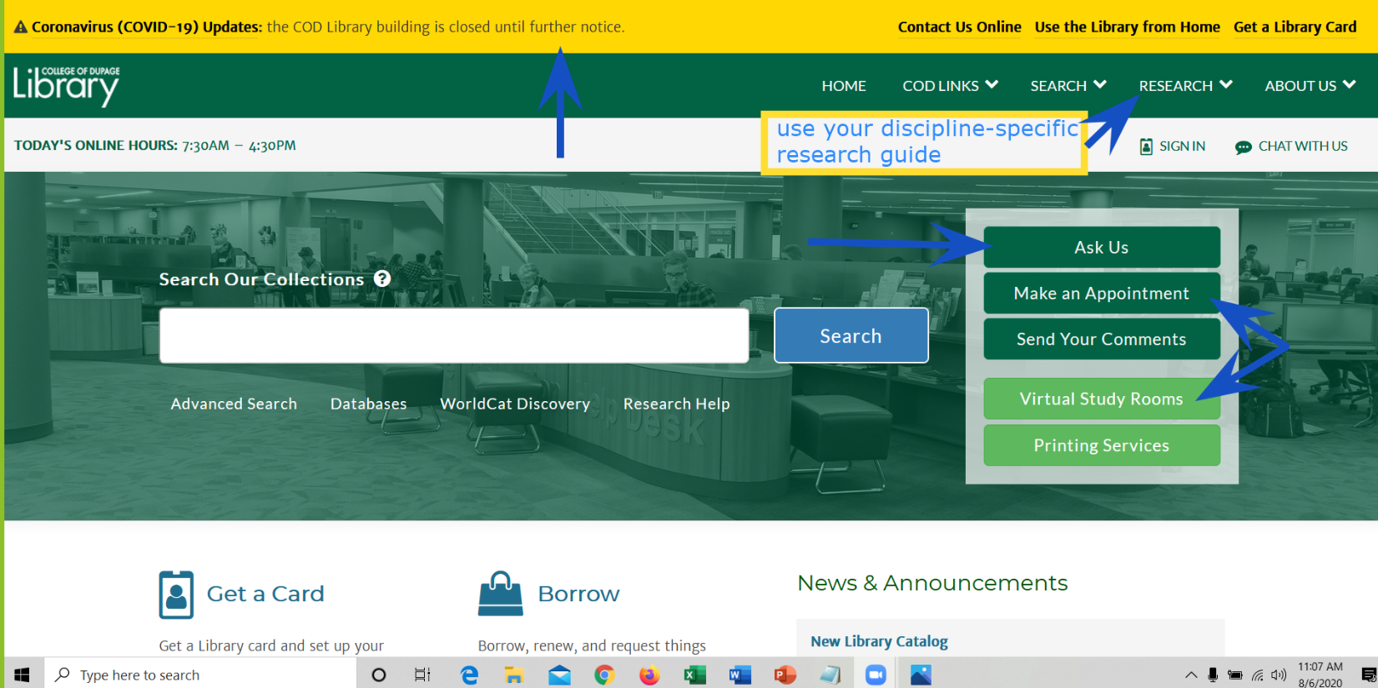
- Check the yellow status bar at the top of all Library pages for COVID-19 related updates
- Bookmark the Nursing Resource Guide for access to course-specific research handouts, “best bet” Ebooks, APA guidance, drug resources and CINAHL (your go-to journal article database for nursing)
- Access the Library’s FREE Ebooks, full-text journal articles & streaming videos 24/7 using your COD Network ID
- Use our Grab & Go contact-less service to access print nursing and health science resources
- Request a “Virtual Study Room” to practice presentations, study with friends & perform group work
- Receive research assistance 7-days a week via chat, email, phone or video appointments via the Ask Us button
- Schedule a video research appt with Debra (your HS Librarian) via the button located on the Nursing Resource guide or by emailing Debra directly (smithkak@cod.edu)
library.cod.edu Research (top right) Research GuidesNursing (ADN, BNA, PN)
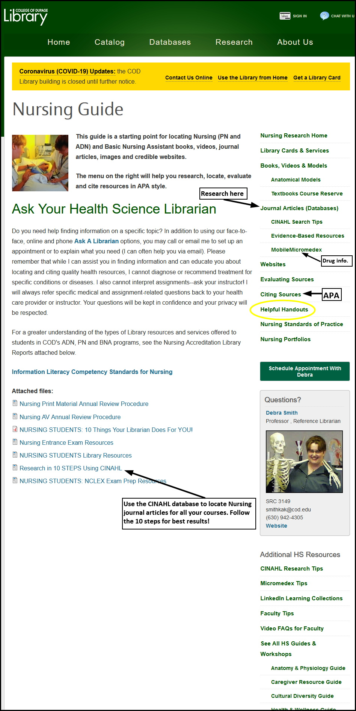
Feel the Librarian Love! My Nursing Guide will hook you up!
Schedule an individual or group video appointment with Debra!
Drug Information
The Library contains multiple print & Ebook drug handbooks, manuals and resources (see “reference” section of books, videos & models tab of the Nursing guide)
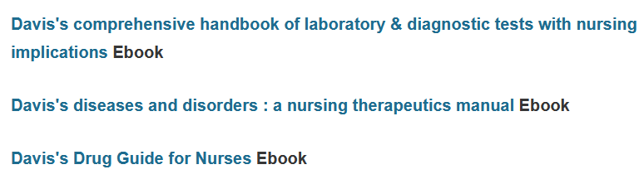
and the Websites section of the guide links to various Internet (freely available) sites.
Your BEST BET and most credible drug resource is the database, Micromedex.
Micromedex
**Access from on campus is automatic. Access from off campus requires COD network credentials** The “Download Mobile Apps” link contains passwords for free downloads—check COD’s Micromedex download page FREQUENTLY as passwords change often with updates!
- Micromedex is an evidence-based, search engine that provides in-depth information for drugs (both prescription and over-the-counter products), diseases, toxicology, and alt. med.
- Clinical tools include IV compatibility, drug identification, drug interactions, drug comparison, and clinical calculators.
- It also provides patient education (CareNotes) for medications, procedures, and conditions.
** Micromedex has FREE mobile apps for Apple & Android devices**
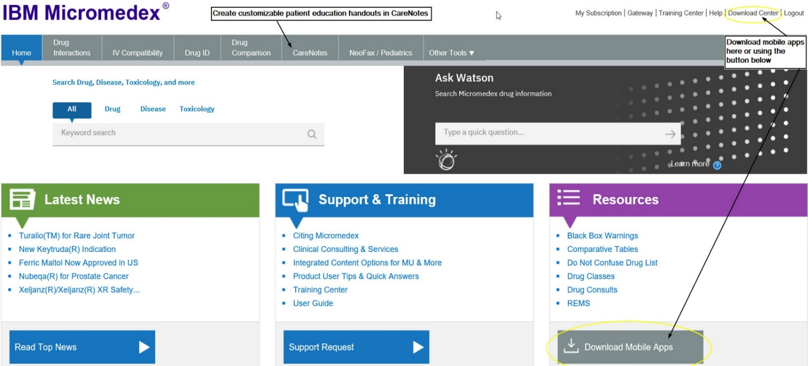

Customizable Patient Education Resources
CareNotes (available from within Micromedex)
- CareNotes documents provide easy-to-understand information about all aspects of care and health. Presented in English and Spanish (and up to 13 other languages), the System's concise, customizable materials address patient condition, treatment, laboratory tests, follow-up care, psychosocial issues, continuing health, and the most frequently administered drugs. CareNotes helps meet JCAHO patient education guidelines.
LOCATING NURSING ARTICLES & CLINICAL RESEARCH
Your BEST BET database for locating Nursing journal articles is CINAHL Complete.
- The Cumulative Index to Nursing & Allied Health Literature, (CINAHL) covers nursing, allied health, biomedical and consumer health journals, publications of the American Nursing Association, and the National League for Nursing. It includes the CINAHL Thesaurus and full text of over 1300 important nursing and clinical journals plus Evidence-based Care Sheets; Quick Lessons providing Overviews of Disease and Conditions; AND Continuing Education [CEUs].

**See the CINAHL Search Tips link under Journal Articles (Databases) on the right-hand Nursing Guide navigation menu for definitions and step-by-step search help**
Need articles from Nursing journals for your course assignments? Follow the directions in the Research in 10 STEPS Using CINAHL handout!
APA CITATION AND DOCUMENT FORMATTING ASSISTANCE
Click on the Citing Sources link on the right-hand Nursing guide navigation menu
If you take ONE thing away from this handout, let it be this:
You are NOT alone. Help is available—all you have to do is ASK @ the COD Library!
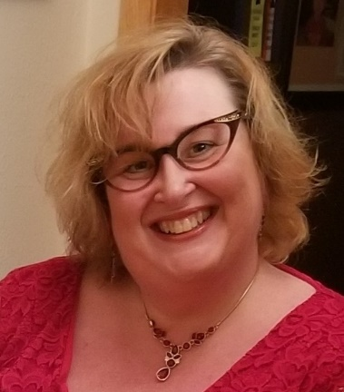
Your “Personal
Professor Debra J. Kakuk Smith, MA, MLIS
Health Sciences Librarian
Office: SRC 3149 (Upper Level, Library)
Email: smithkak@cod.edu
Librarian”

